ETL Project

**Coast 2 Coast Cuisine**

December 15, 2018

Audrey Bouldin

Nichelle Nesbitt

Table of Contents

Goal 2

Objective 2

Guidelines/Criteria 2

Extracting Data 3

Transforming Data 4

Loading Data in to Database 10

Observations/Findings 11

Learnings 15

Results 15

# Goal

Evaluate restaurants in two cities regarding their food inspections grades. Use this data to give recommendations on locations to eat.

# Objective

Perform ETS while using two (2) or more sources of data. Create a final production database and load it into a relational or non-relational source.

# Guidelines/Criteria

Use data food inspection reports for the cities of Los Angeles and New York City.

Use the last 3 full years of data for the analysis.

Locations with “A” ratings have been identified a “excellent” restaurants.

The City of Angels (Los Angeles) is being used as representation of the West Coast cuisine.

The Big Apple (New York City) is being used as representation of the East Coast cuisine.

Any PASSWORD information will be referred to as “PASSWORD” and not shown in writing.

# 

# Extracting Data

Used the following data from Kaggle.com for the analysis:

<https://www.kaggle.com/meganrisdal/la-county-restaurant-inspections-and-violations>

<https://www.kaggle.com/new-york-city/nyc-inspections>

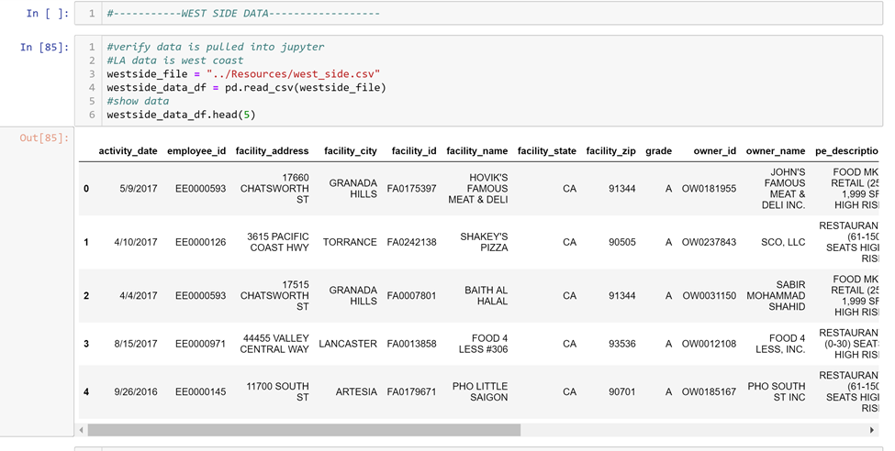

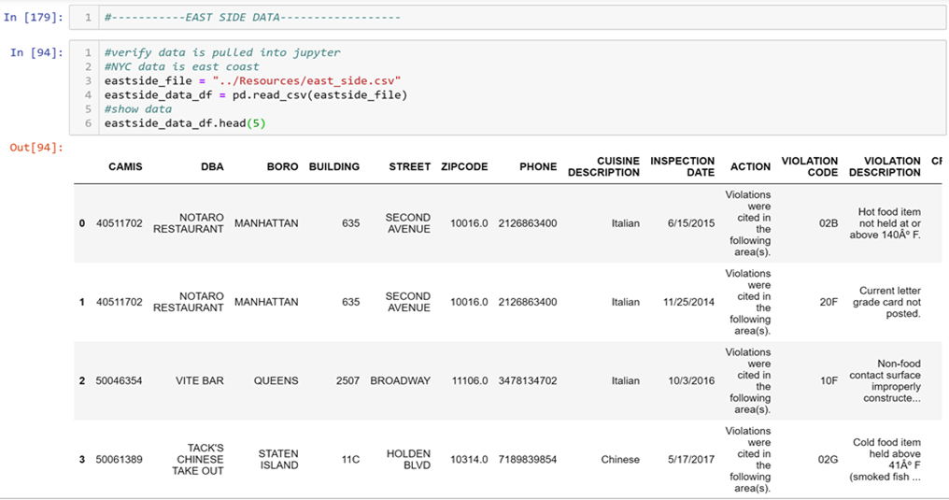

# Transforming Data

**CHANGING DATE:**

Desired to have data for the last 3 full calendar years. This would include years 2015, 2016, and 2017. See below, data was transformed to add 4 digit year.

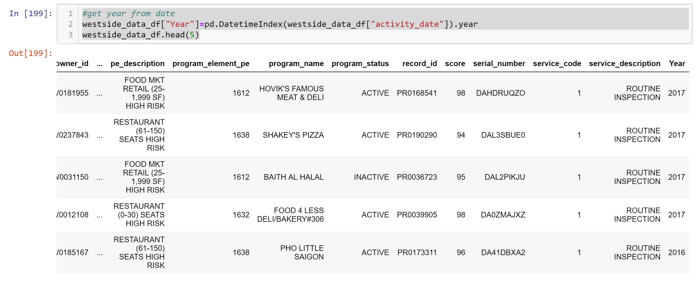

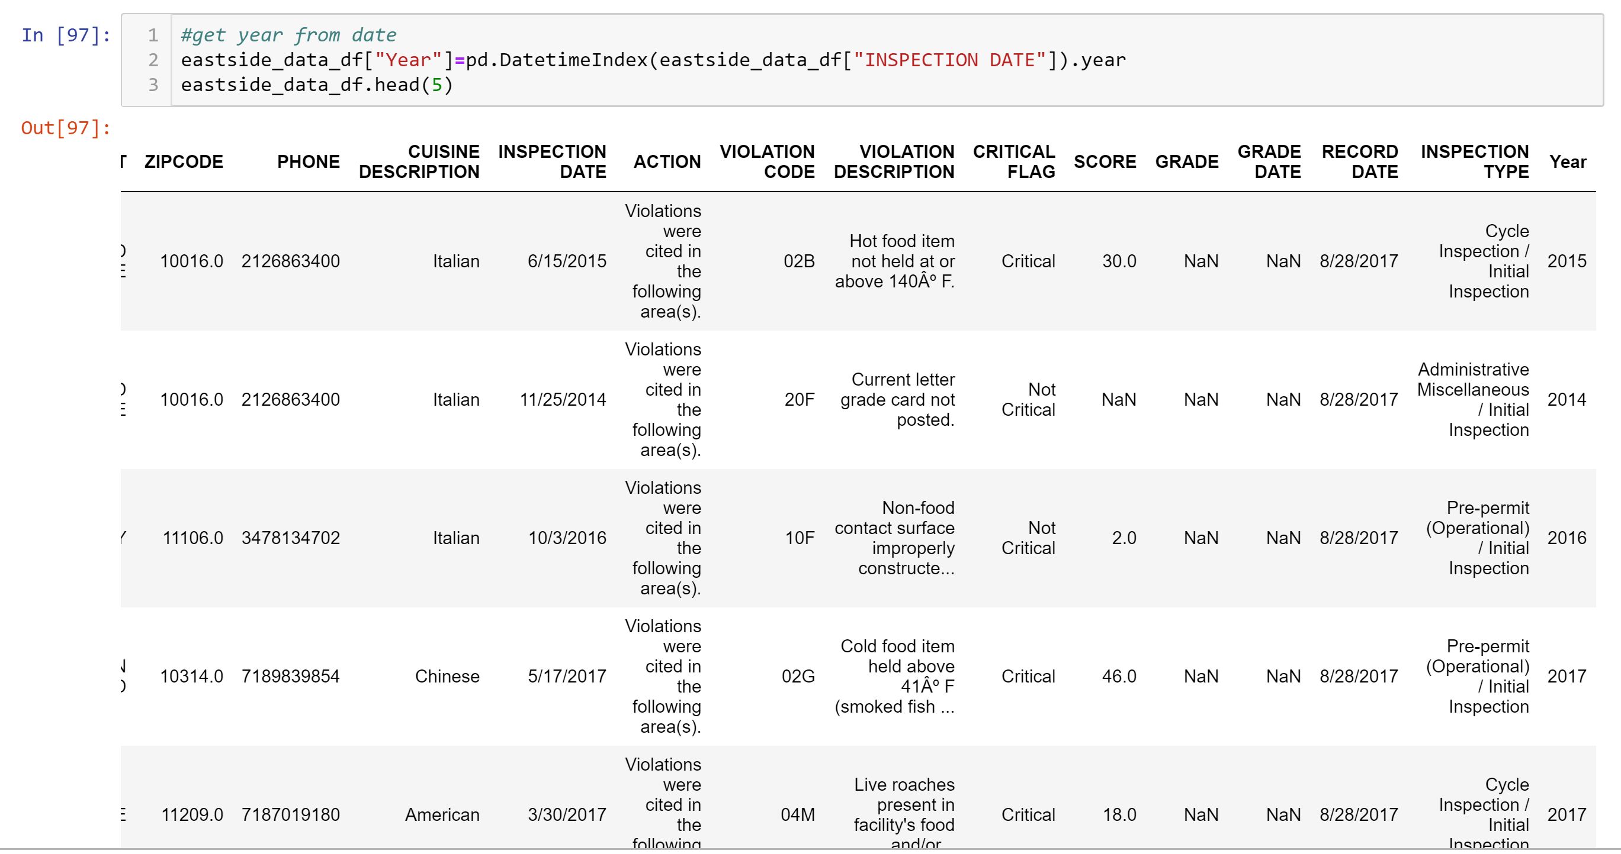

**IDENTIFYING WESTSIDE AND EASTSIDE LOCATIONS:**

See below, location was added based whether it was located on the westside or eastside.

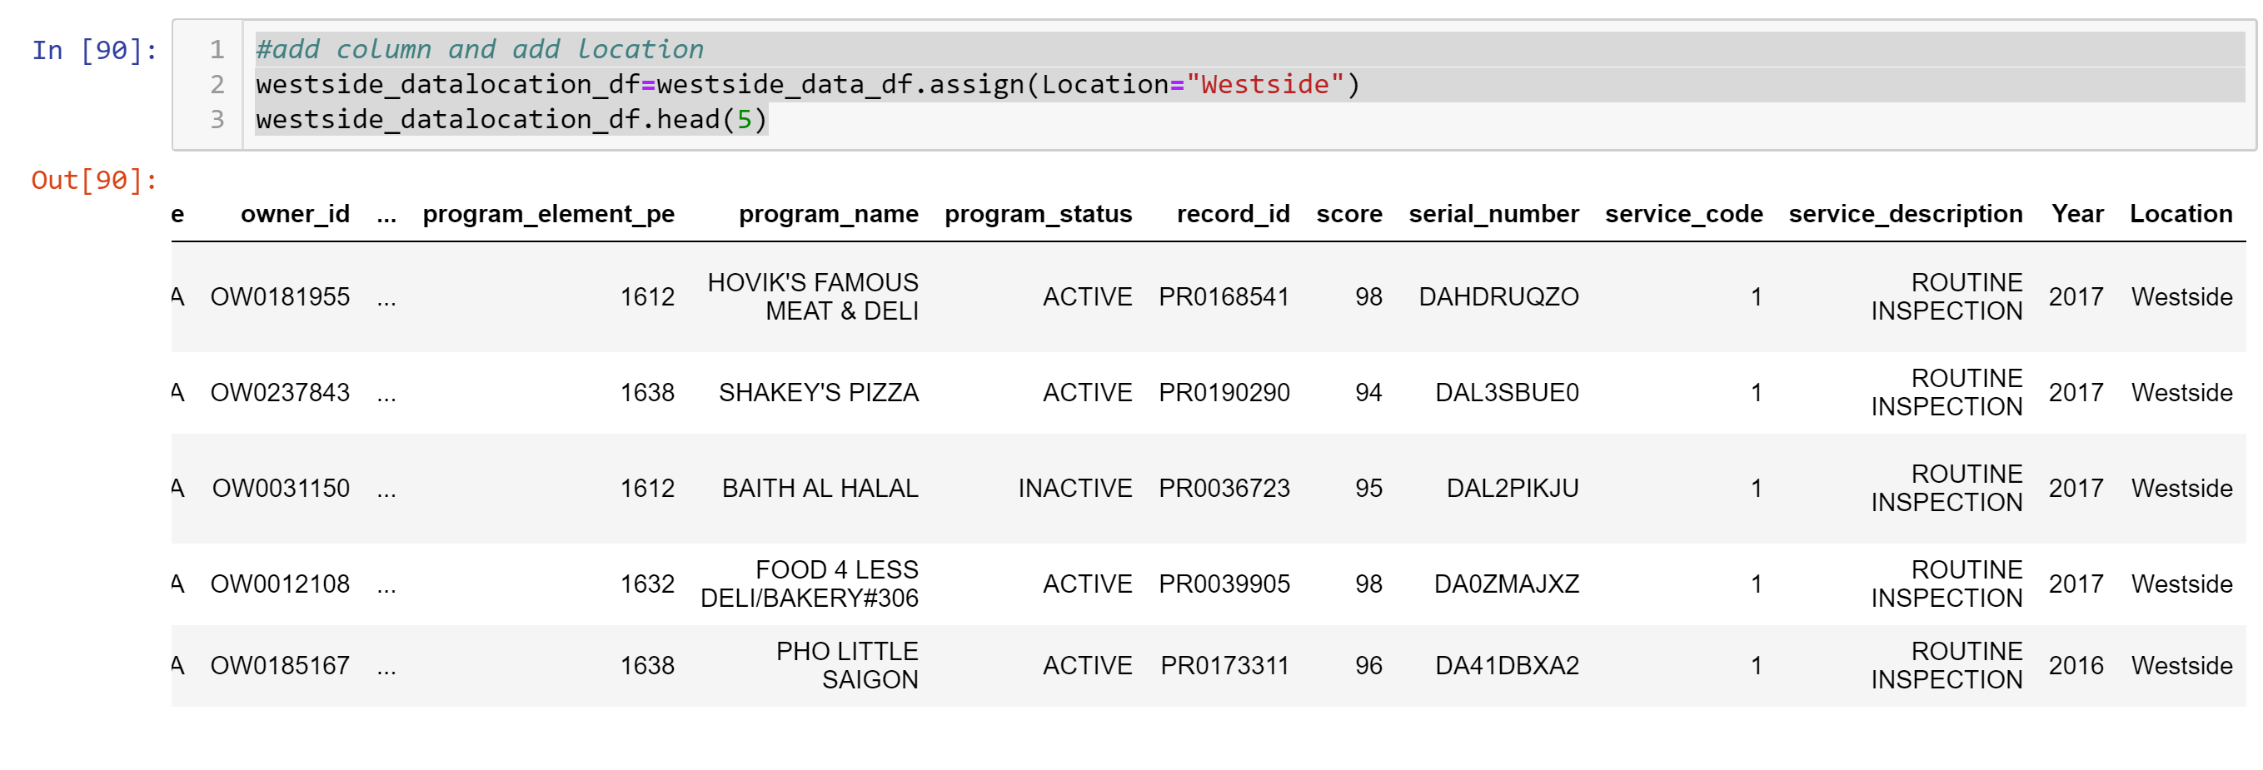

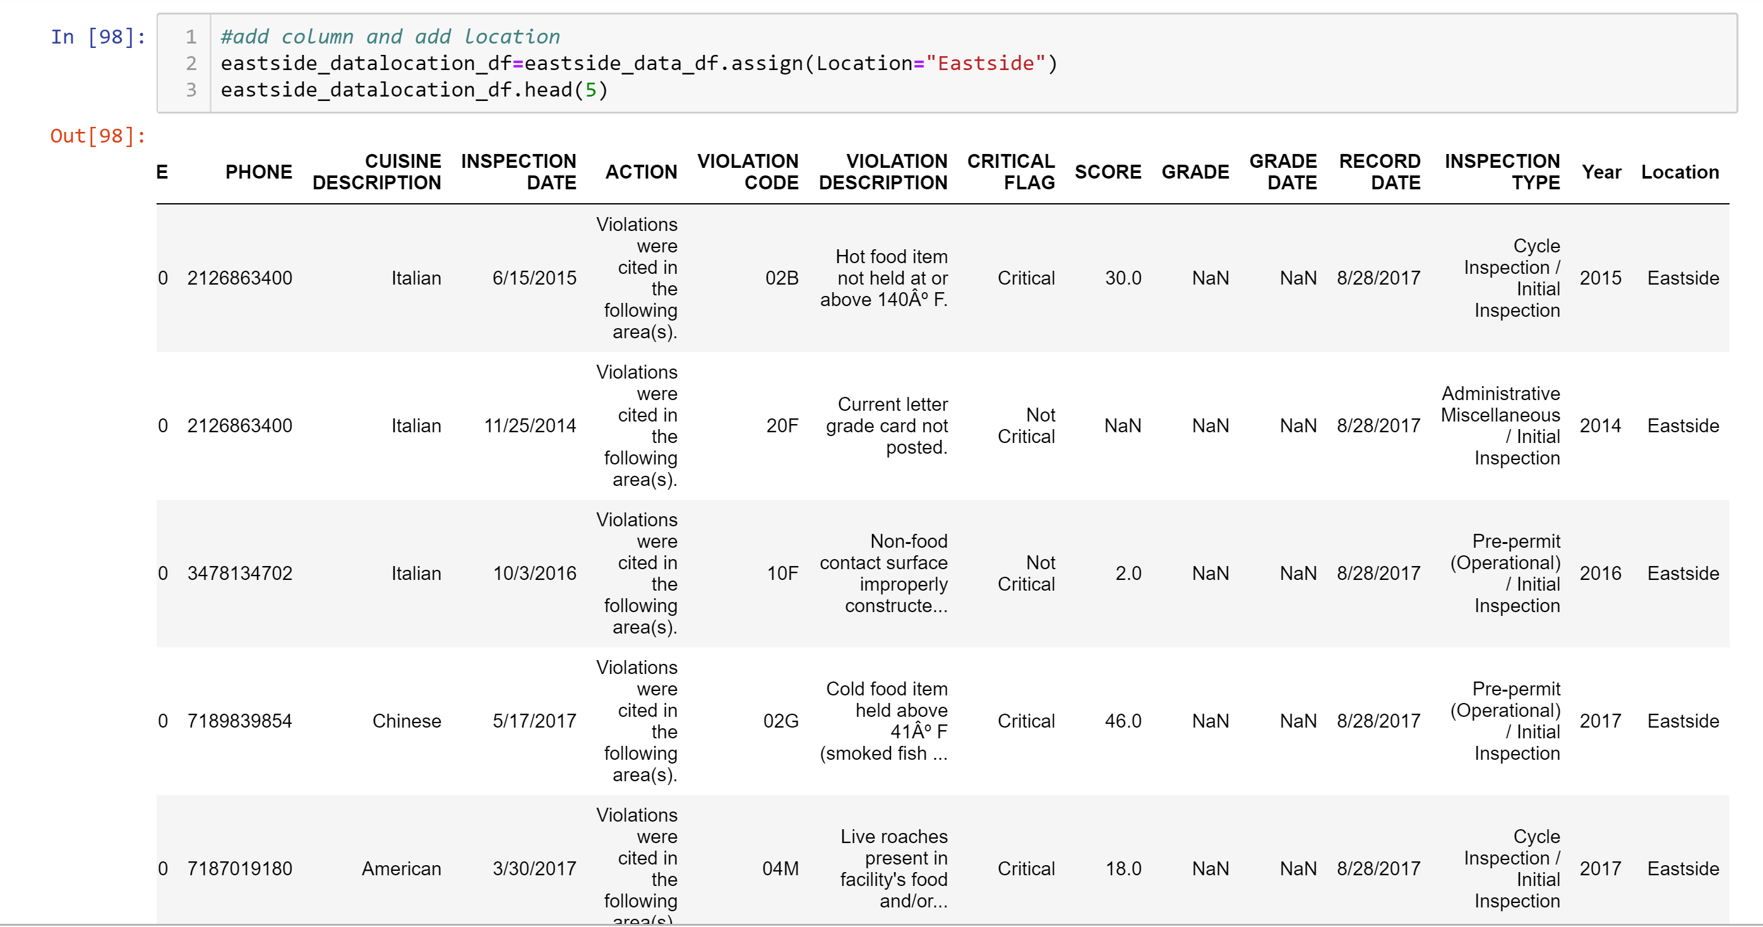

**SELECTING ONLY THE COLUMNS NEEDED FOR THE ANALYSIS:**

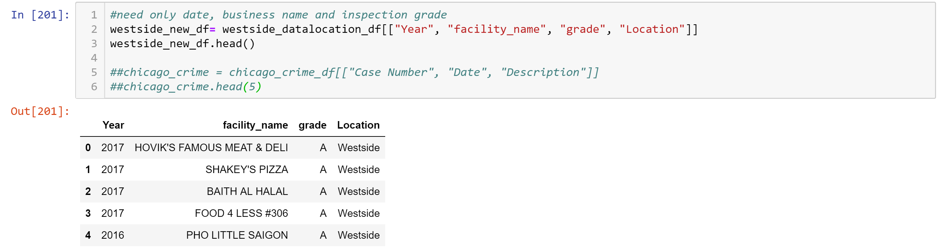

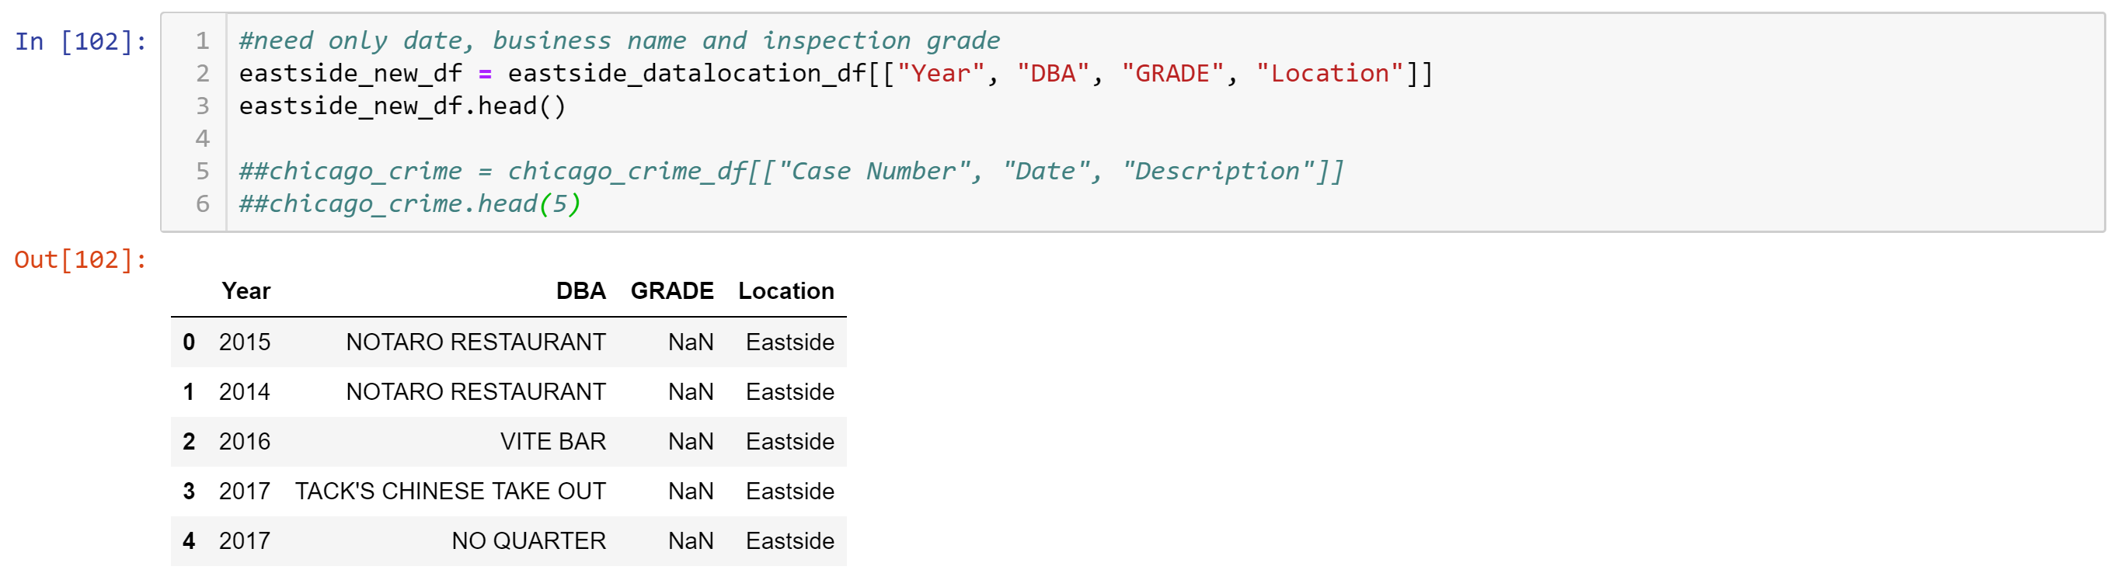

**DROPPING “BLANK” DATA:**

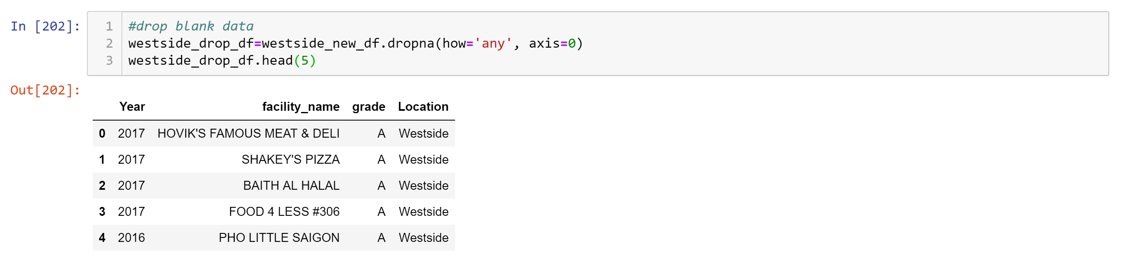

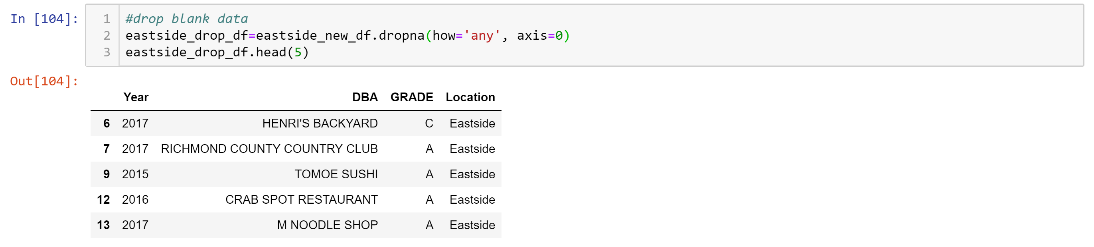

**SELECTING YEARS NEEDED FOR ANALYSIS:**

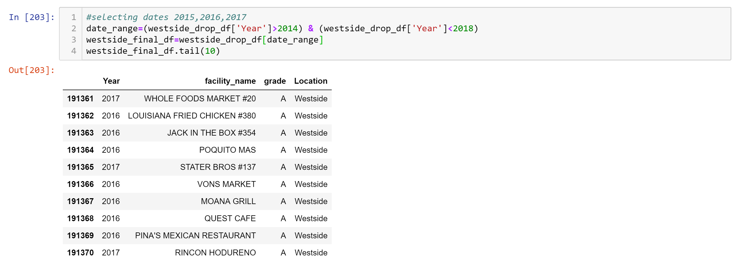

# 

**VALIDATING THAT ALL DATA WAS DROPPED:**

Since the COUNT is the same for all variables, the dropped cells have been removed and we are working complete data sets in regard to each variable.

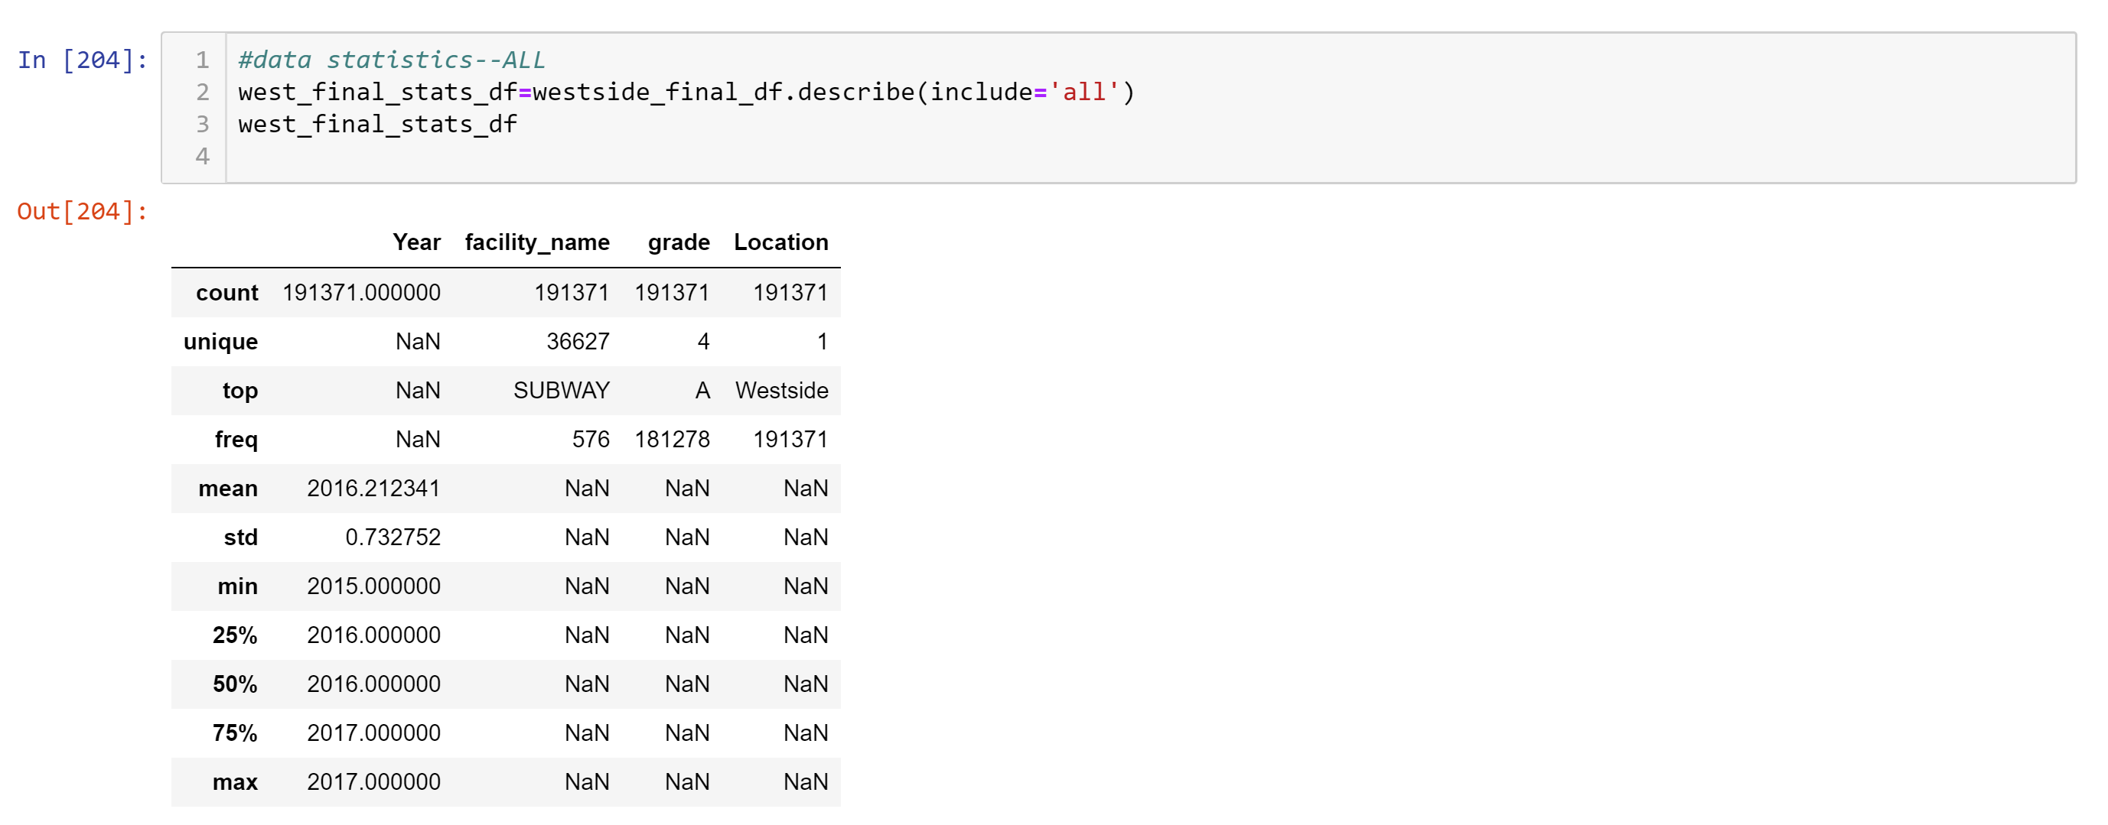

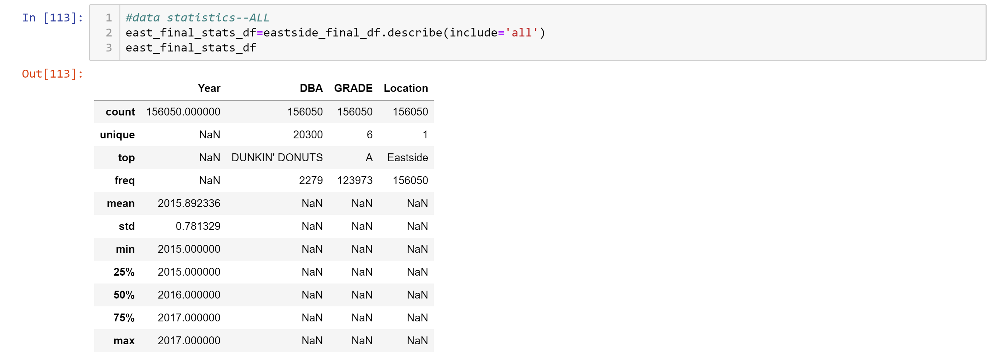

**RENAMING COLUMNS FOR CONSISTENCY WESTSIDE AND EASTSIDE DATA:**

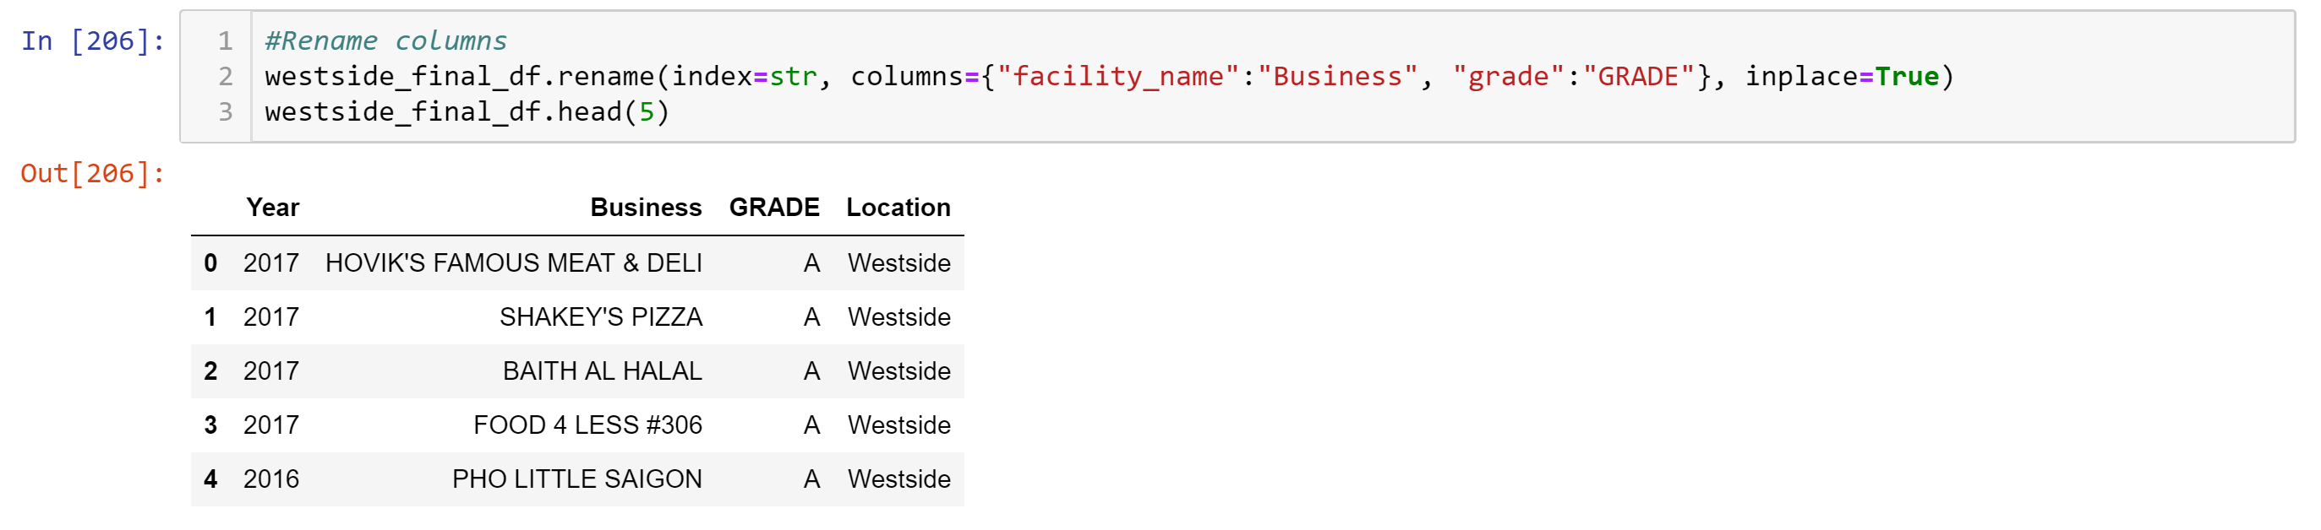

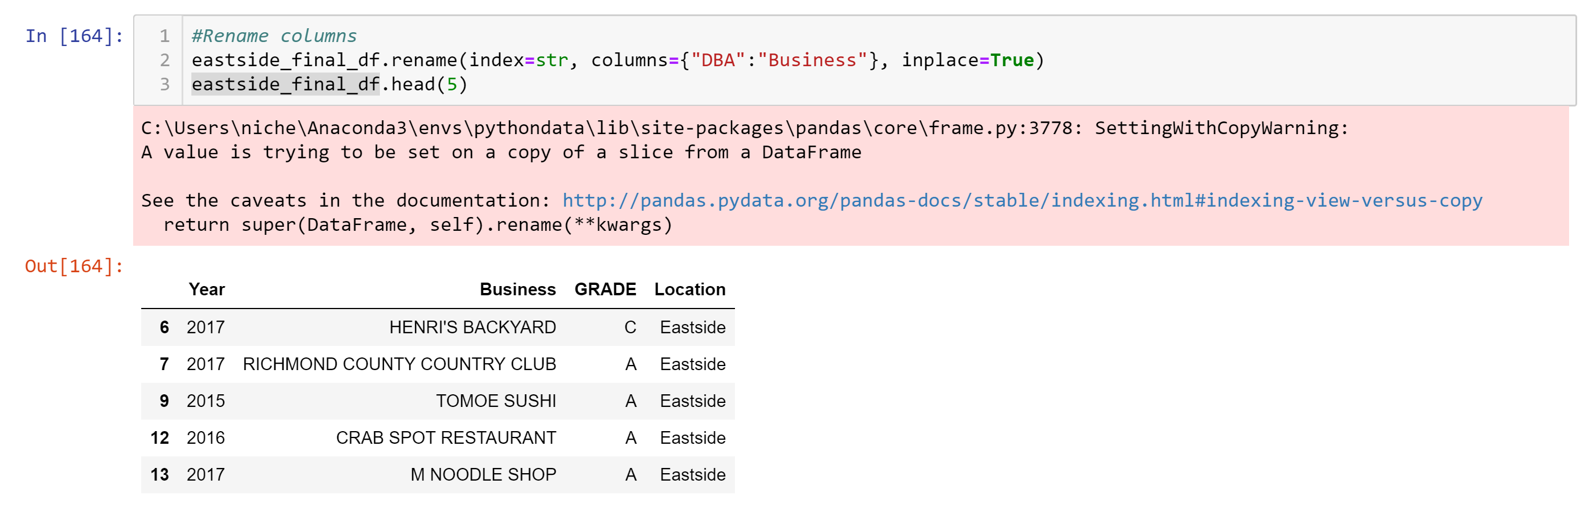

# 

# Loading Data in to Database

We chose to use a rational database and prepared to load the data into MySQL via the following steps. We loaded two separate tables (westside and eastside).

50 rows of data were selected to make data manageable during the loading into MySQL. This data will be representative of our overall data sets for our analysis.

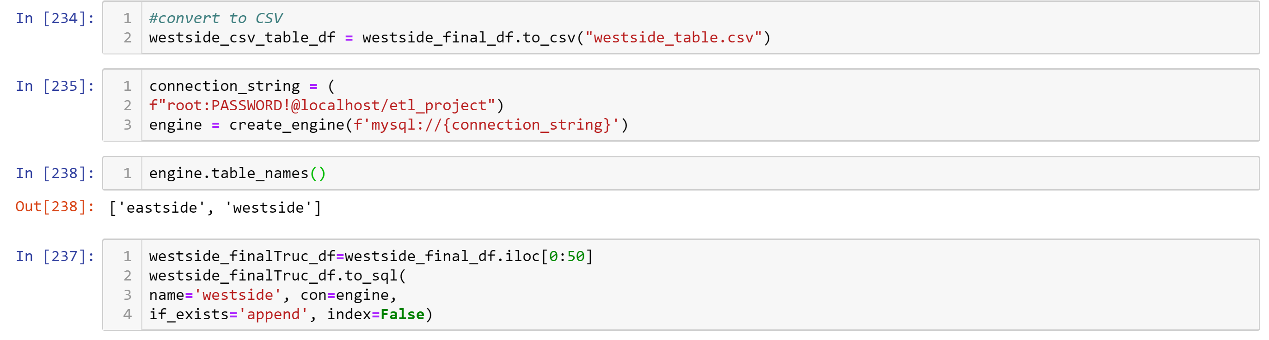

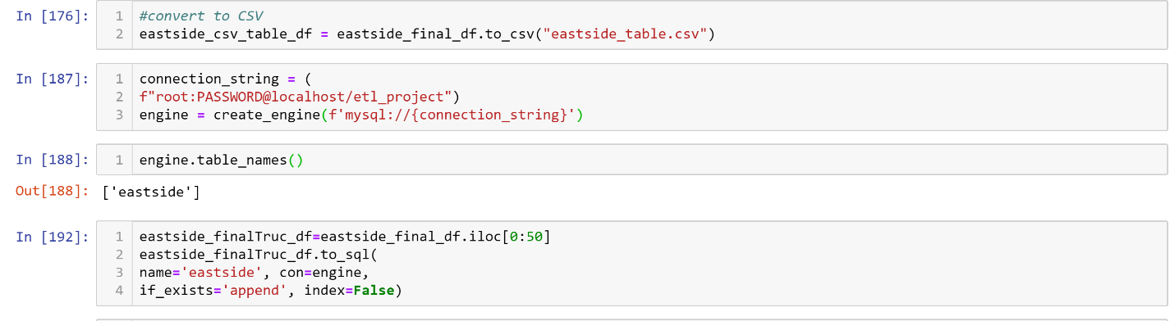

# Observations/Findings

Westside data comprised of 191371 inspections

Eastside data comprised of 156050 inspections

We have 39 restaurants with a grade of an A for the Westside.

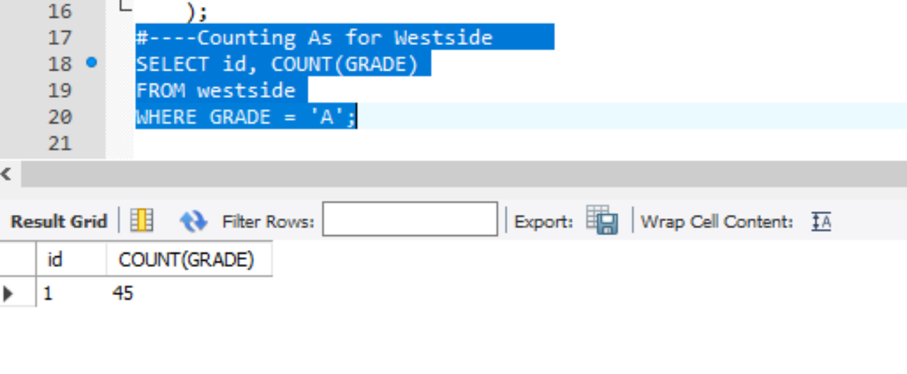

We have 45 restaurants with a grade of an A for the Eastside.

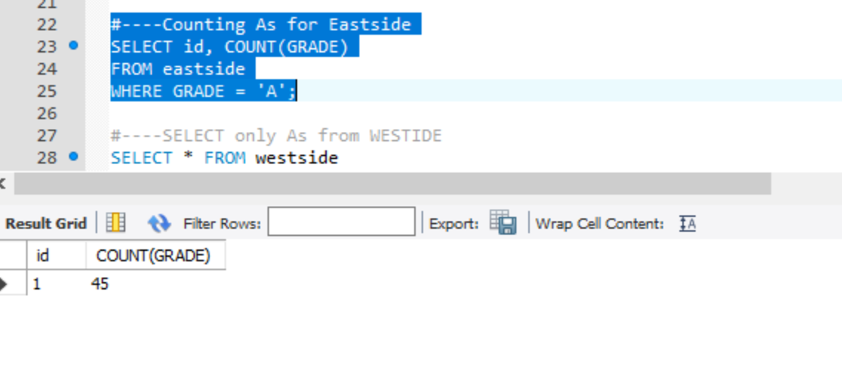

A—grade by year for WESTSIDE:

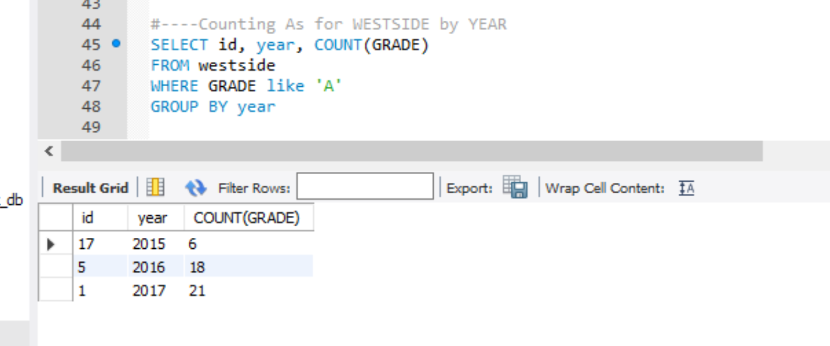

A—grade by year for EASTSIDE:

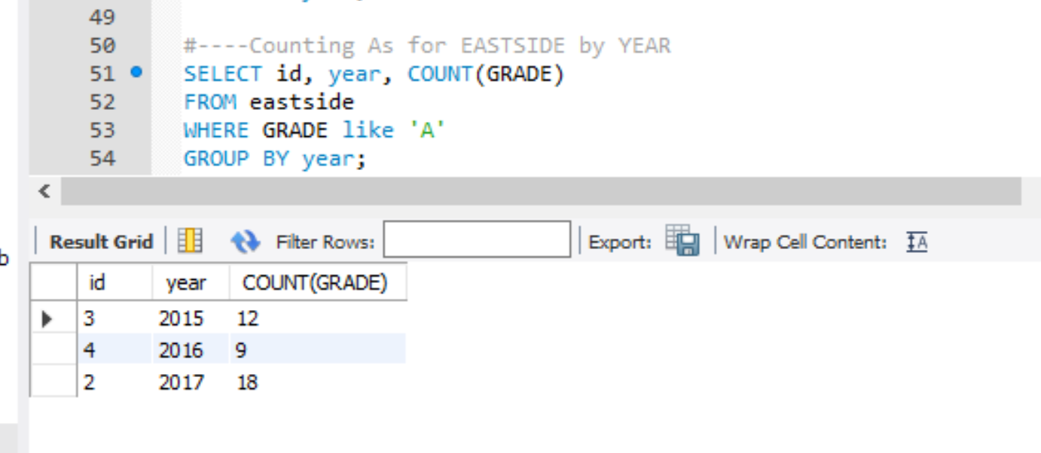

TOTAL list of all of restaurants and grades

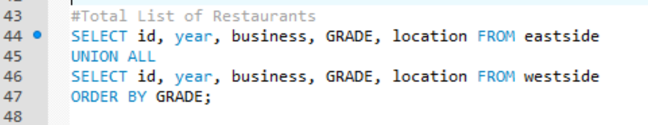

|  |  |  |  |  |
| --- | --- | --- | --- | --- |
| 2 | 2017 | RICHMOND COUNTY COUNTRY CLUB | A | Eastside |
| 3 | 2015 | TOMOE SUSHI | A | Eastside |
| 4 | 2016 | CRAB SPOT RESTAURANT | A | Eastside |
| 5 | 2017 | M NOODLE SHOP | A | Eastside |
| 6 | 2017 | LOWER SUITES STOLI BAR SOUTH CLUB LOUNGE | A | Eastside |
| 7 | 2017 | AN BEAL BOCHT CAFE | A | Eastside |
| 8 | 2016 | SERVICE BAR 7 | A | Eastside |
| 9 | 2016 | TROPICAL REVIVAL RESTAURANT & CATERING | A | Eastside |
| 10 | 2016 | ICHI UMI | A | Eastside |
| 11 | 2015 | ANABLE BASIN SAILING | A | Eastside |
| 12 | 2015 | MR. WONTON | A | Eastside |
| 13 | 2017 | BEST EAST STAR RESTAURANT | A | Eastside |
| 14 | 2017 | KBBQ | A | Eastside |
| 15 | 2015 | HUDSON'S MARKET @ SHERATON NEW YORK | A | Eastside |
| 17 | 2016 | LEMON LEAVES | A | Eastside |
| 18 | 2017 | WENDY'S | A | Eastside |
| 19 | 2015 | GULLUOGLU BAKLAVA & CAFE | A | Eastside |
| 21 | 2017 | BROOK AVENUE DELI & PIZZA | A | Eastside |
| 22 | 2015 | STARBUCKS | A | Eastside |
| 23 | 2016 | BEAN N BEAN | A | Eastside |
| 24 | 2017 | ARMANDO'S PIZZA | A | Eastside |
| 25 | 2017 | MCDONALD'S | A | Eastside |
| 27 | 2016 | TOKYO BAY | A | Eastside |
| 29 | 2015 | HUNGRY BIRD | A | Eastside |
| 30 | 2016 | TWO DOOR TAVERN | A | Eastside |
| 32 | 2015 | 28 NOODLES | A | Eastside |
| 33 | 2015 | EMPORIUM BRASIL RESTAURANT | A | Eastside |
| 34 | 2016 | THE JUILLIARD SCHOOL(ROSE CAFE) | A | Eastside |
| 36 | 2017 | ANGELA'S BAKERY | A | Eastside |
| 37 | 2015 | FORTUNATA'S II | A | Eastside |
| 39 | 2017 | SALAD SHACK | A | Eastside |
| 40 | 2017 | PIZZA SHACK | A | Eastside |
| 42 | 2015 | JOHNNY'S GRILL | A | Eastside |
| 44 | 2017 | THE BAYHOUSE | A | Eastside |
| 46 | 2017 | PUNJABI INDIAN & AMERICAN RESTAURANT | A | Eastside |
| 47 | 2017 | BOCAITO CAFE & WINE BAR | A | Eastside |
| 48 | 2017 | DUNKIN' DONUTS | A | Eastside |
| 49 | 2015 | INDO-PAK HALAL RESTAURANT | A | Eastside |
| 50 | 2017 | UMAMI BURGER | A | Eastside |
| 1 | 2017 | HOVIK'S FAMOUS MEAT & DELI | A | Westside |
| 2 | 2017 | SHAKEY'S PIZZA | A | Westside |
| 3 | 2017 | BAITH AL HALAL | A | Westside |
| 4 | 2017 | FOOD 4 LESS #306 | A | Westside |
| 5 | 2016 | PHO LITTLE SAIGON | A | Westside |
| 6 | 2016 | HAPPY TACOS TO GO | A | Westside |
| 8 | 2016 | THE NICKEL DINER | A | Westside |
| 9 | 2016 | FULL OF LIFE BAKERY | A | Westside |
| 10 | 2017 | CARSON LIQUOR | A | Westside |
| 12 | 2016 | GREAT KHAN'S | A | Westside |
| 13 | 2017 | FABULOUS GRILL | A | Westside |
| 14 | 2016 | TRADER JOE'S #54 | A | Westside |
| 15 | 2017 | TRIMANA OF CALIFORNIAMART | A | Westside |
| 16 | 2016 | COJUTEPEQUE RESTAURANT | A | Westside |
| 17 | 2015 | PRINKIPIA | A | Westside |
| 18 | 2017 | VILLAGE TANDOOR | A | Westside |
| 19 | 2015 | FONDA DON CHON | A | Westside |
| 20 | 2017 | WINGSTOP #465 | A | Westside |
| 21 | 2016 | MCDONALD'S #30907 | A | Westside |
| 22 | 2016 | AMC DINE-IN SUNSET 5 | A | Westside |
| 23 | 2017 | MIMI'S CAFE | A | Westside |
| 25 | 2016 | MARAN RESTAURANT | A | Westside |
| 26 | 2017 | CARL'S JR #24 | A | Westside |
| 27 | 2017 | SEOUL SOONDAE | A | Westside |
| 28 | 2015 | MOON DONUTS | A | Westside |
| 30 | 2015 | SADDLE RANCH CHOP HOUSE | A | Westside |
| 31 | 2017 | RUBIO'S FRESH MEXICAN GRILL #132 | A | Westside |
| 33 | 2016 | JIM'S BURGERS | A | Westside |
| 34 | 2017 | QUIERO MAS TACOS | A | Westside |
| 35 | 2016 | SAMARITAN  MEDICAL TOWER PHARMACY | A | Westside |
| 36 | 2017 | TRIMANA | A | Westside |
| 37 | 2016 | HOT OVEN | A | Westside |
| 38 | 2017 | MCDONALD'S | A | Westside |
| 39 | 2017 | SPICE AFFAIR | A | Westside |
| 40 | 2017 | CATALINA CANTINA | A | Westside |
| 41 | 2016 | FIESTA MEXICANA FAMILY REST | A | Westside |
| 42 | 2017 | EL POLLO LOCO #5979 | A | Westside |
| 43 | 2016 | THE FLAME BROILER | A | Westside |
| 44 | 2017 | MRS FIELD'S COOKIES | A | Westside |
| 45 | 2017 | WHICH WICH | A | Westside |
| 46 | 2016 | ALI BABA | A | Westside |
| 47 | 2016 | DODGER STADIUM | A | Westside |
| 48 | 2016 | MON-LAND HOT POT CITY | A | Westside |
| 49 | 2015 | DENNY'S RESTAURANT #2125 | A | Westside |
| 50 | 2015 | COFFEE BEAN & TEA LEAF #348 | A | Westside |
| 16 | 2016 | MANOLO TAPAS RESTAURANT | B | Eastside |
| 26 | 2017 | Little Italy | B | Eastside |
| 31 | 2015 | Daisy's Diner | B | Eastside |
| 35 | 2015 | JOE'S PIZZA | B | Eastside |
| 38 | 2015 | GOOD TO GO | B | Eastside |
| 41 | 2015 | V {iv} Thai Restaurant & Bar | B | Eastside |
| 7 | 2017 | EL POTRERO CLUB | B | Westside |
| 11 | 2016 | SABOR MEXICANO RESTAURANT | B | Westside |
| 24 | 2017 | THAI MOON RESTAURANT | B | Westside |
| 29 | 2017 | PETE'S CAFE | B | Westside |
| 32 | 2016 | TORAJI RAMEN | B | Westside |
| 1 | 2017 | HENRI'S BACKYARD | C | Eastside |
| 28 | 2016 | PLAZA TULCINGO RESTAURANT | C | Eastside |
| 45 | 2015 | GOOD ENOUGH TO EAT (A.G. BISTRO) | C | Eastside |
| 43 | 2017 | CHIVE BLOSSOM | Not Yet Graded | Eastside |
| 20 | 2017 | CHINA WOK II | Z | Eastside |

# Learnings

Revisited rational and non-rational data sets.

Large data sets are difficult to load into other systems (i.e., Github Repository and MySQL Workbench). We had to get creative with the ETL process.

Although we could have added more columns from the original data, to add more scenarios to the MySQL aggregation, the limitation on loading the data was a huge constraint.

We are truly “hands on learners”. Performing the ETL process was very helpful.

It is important assign data correctly in MySQL. CONVERT was one of the many new functions learned and considered.

# Results

Based on our samples used and aggregated in MySQL, we recommend the following list of restaurants as having “EXCELLENT” cuisine . These locations have A grades with 1 location pending a review. The west coast has the most A grades totaling 45 successful inspections over the last 3 years evaluated. Therefore we are recommending the restaurants on the west coast as being the “places to eat”. Most of the A grades took place in 2017. The east coast had 39 inspection grades of an A.

id, year, business, GRADE, location

|  |  |  |  |  |
| --- | --- | --- | --- | --- |
| 1 | 2017 | HOVIK'S FAMOUS MEAT & DELI | A | Westside |
| 2 | 2017 | SHAKEY'S PIZZA | A | Westside |
| 3 | 2017 | BAITH AL HALAL | A | Westside |
| 4 | 2017 | FOOD 4 LESS #306 | A | Westside |
| 5 | 2016 | PHO LITTLE SAIGON | A | Westside |
| 6 | 2016 | HAPPY TACOS TO GO | A | Westside |
| 8 | 2016 | THE NICKEL DINER | A | Westside |
| 9 | 2016 | FULL OF LIFE BAKERY | A | Westside |
| 10 | 2017 | CARSON LIQUOR | A | Westside |
| 12 | 2016 | GREAT KHAN'S | A | Westside |
| 13 | 2017 | FABULOUS GRILL | A | Westside |
| 14 | 2016 | TRADER JOE'S #54 | A | Westside |
| 15 | 2017 | TRIMANA OF CALIFORNIAMART | A | Westside |
| 16 | 2016 | COJUTEPEQUE RESTAURANT | A | Westside |
| 17 | 2015 | PRINKIPIA | A | Westside |
| 18 | 2017 | VILLAGE TANDOOR | A | Westside |
| 19 | 2015 | FONDA DON CHON | A | Westside |
| 20 | 2017 | WINGSTOP #465 | A | Westside |
| 21 | 2016 | MCDONALD'S #30907 | A | Westside |
| 22 | 2016 | AMC DINE-IN SUNSET 5 | A | Westside |
| 23 | 2017 | MIMI'S CAFE | A | Westside |
| 25 | 2016 | MARAN RESTAURANT | A | Westside |
| 26 | 2017 | CARL'S JR #24 | A | Westside |
| 27 | 2017 | SEOUL SOONDAE | A | Westside |
| 28 | 2015 | MOON DONUTS | A | Westside |
| 30 | 2015 | SADDLE RANCH CHOP HOUSE | A | Westside |
| 31 | 2017 | RUBIO'S FRESH MEXICAN GRILL #132 | A | Westside |
| 33 | 2016 | JIM'S BURGERS | A | Westside |
| 34 | 2017 | QUIERO MAS TACOS | A | Westside |
| 35 | 2016 | SAMARITAN  MEDICAL TOWER PHARMACY | A | Westside |
| 36 | 2017 | TRIMANA | A | Westside |
| 37 | 2016 | HOT OVEN | A | Westside |
| 38 | 2017 | MCDONALD'S | A | Westside |
| 39 | 2017 | SPICE AFFAIR | A | Westside |
| 40 | 2017 | CATALINA CANTINA | A | Westside |
| 41 | 2016 | FIESTA MEXICANA FAMILY REST | A | Westside |
| 42 | 2017 | EL POLLO LOCO #5979 | A | Westside |
| 43 | 2016 | THE FLAME BROILER | A | Westside |
| 44 | 2017 | MRS FIELD'S COOKIES | A | Westside |
| 45 | 2017 | WHICH WICH | A | Westside |
| 46 | 2016 | ALI BABA | A | Westside |
| 47 | 2016 | DODGER STADIUM | A | Westside |
| 48 | 2016 | MON-LAND HOT POT CITY | A | Westside |
| 49 | 2015 | DENNY'S RESTAURANT #2125 | A | Westside |
| 50 | 2015 | COFFEE BEAN & TEA LEAF #348 | A | Westside |